Parking at Pinchbeck surgery

The practice has a clear contractual right for patients to park in front of the branch surgery during their appointment. Please park in the shaded area in the diagram below.

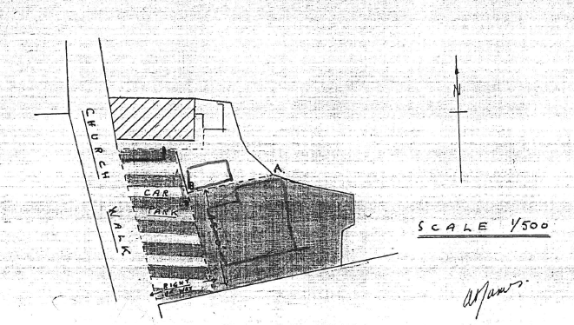

We can only apologise for the poor condition of the car park, which is the property of the hairdresser business next door. We have tried ourselves to maintain the car park but so far have been prevented from doing so by the owner.

